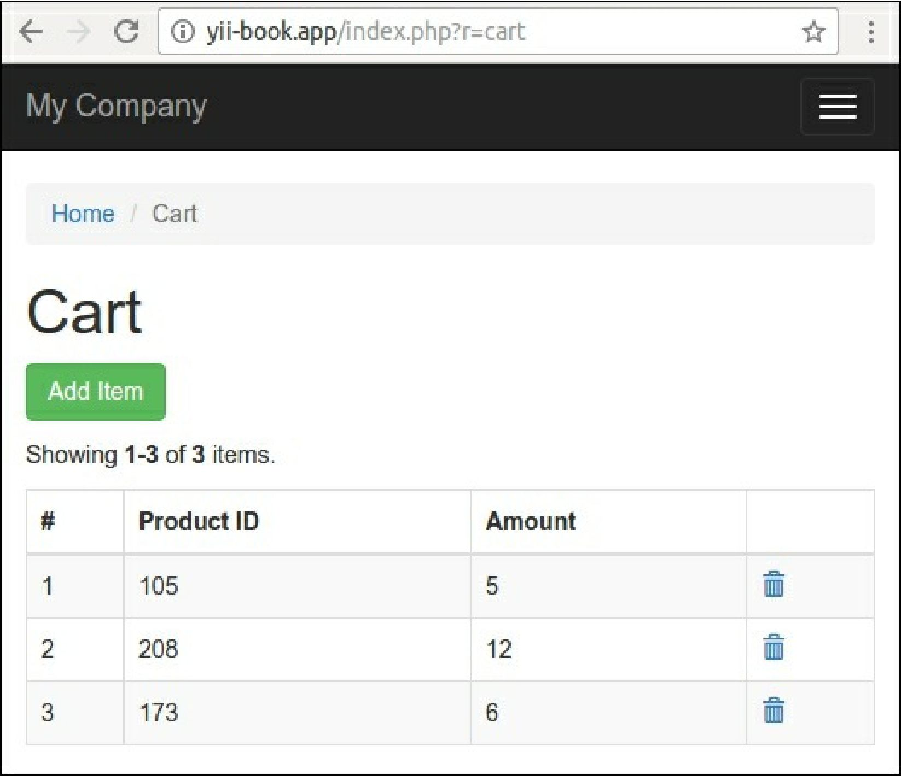

How it works...

First of all we created our own class with a public sessionKey option:

<?php

namespace app\components; use yii\base\Component;

class ShoppingCart extends Component {

public $sessionKey = 'cart';

// ...

}

Secondly, we added the component definition into the components section of the configuration file: 'components' => [

'cart => [